MODULE:5

(JQUERY BASIC,EFFECTS & ADVANCE)

1. What is jQuery?

ANS. jQuery is a small, light –weight and fast javascript of library. it is

Cross- platform and supports different types of browsers. It is also referred as? Write less do more? Because it takes a lot of common tasks that requires many lines of javascript code to accomplish, and binds them into methods than can be called with a single line of code whenever needed. It is also very useful to simplify a lot of the complicated things from javascript, like AJAX call and DOM manipulation.

* jQuery is a small, fast and lightweight javascript library.
* jQuery is platform-independent.
* jQuery means “write less do more”
* Jquery simplifies AJAX call and DOM manipulation,

1. How to apply CSS Using JQuery, How to add class and remove class in jqyery, jquery animation?

Ans. Apply css using JQuery: the css ()method sets or return one or more style properties for the selected elements.

To return the value of a specified css propery.

Exa.css (“propertyname”);

$(“p”).css(“background-color”,”blue”);

Add class and remove class in JQuery:-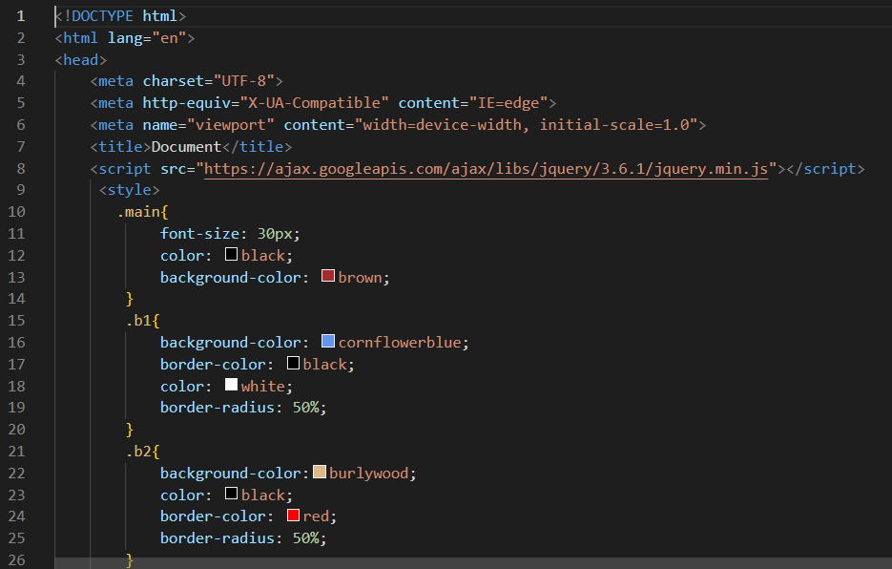

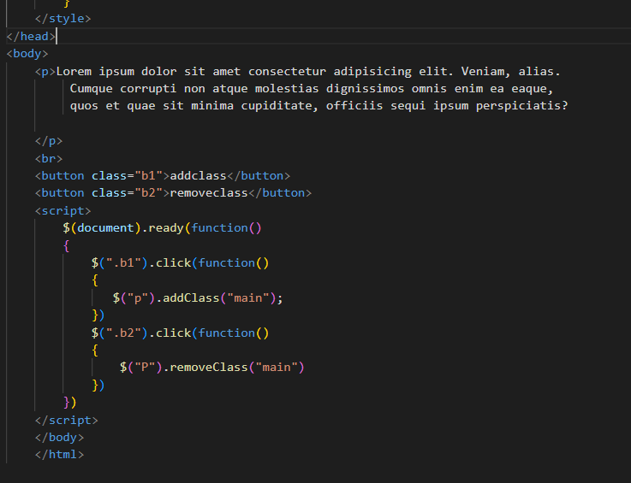

JQuery animation:-

\*hide and show-

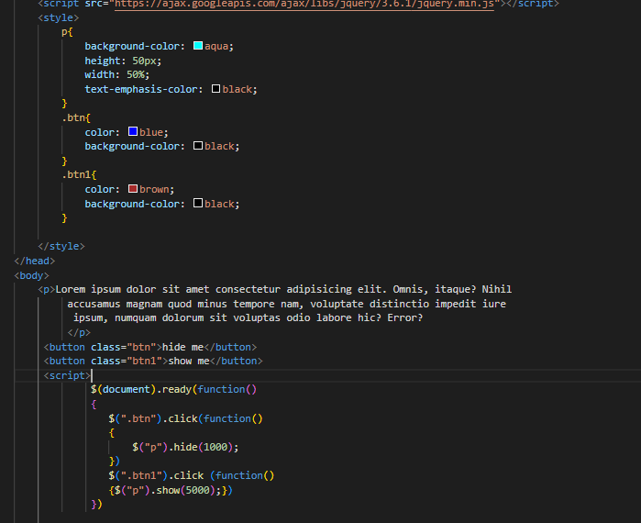

\*fade in and fade out:-

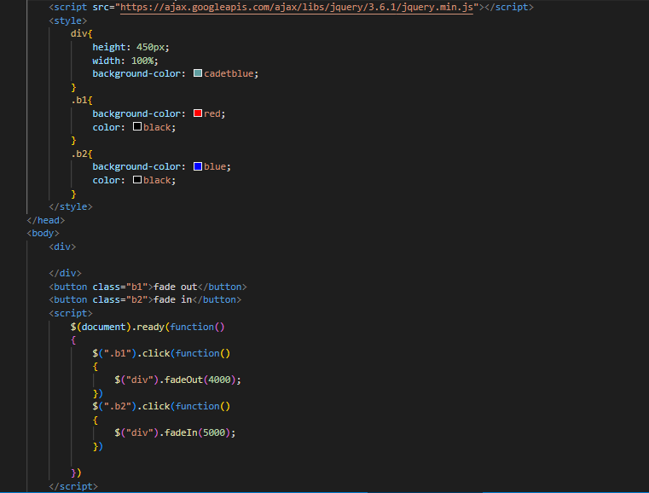

Toggle:-

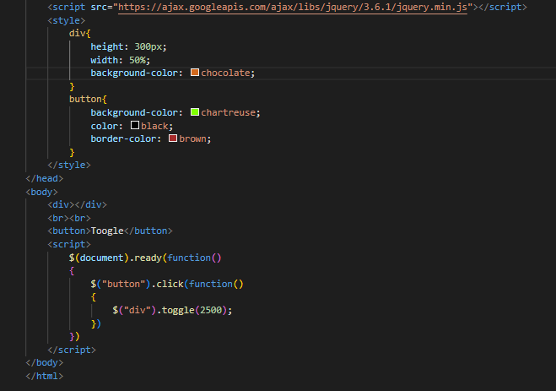

3). How to create slider with animation?

Ans.you can make slider using three types

1. Slidedown()
2. Slideup()
3. Slidetoggle()

\*slidedown and slideup:-

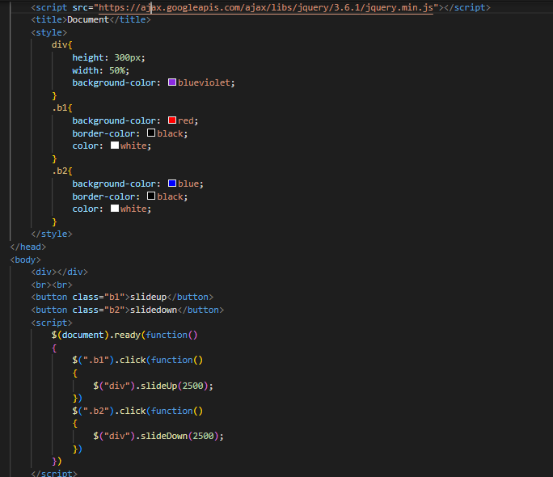

\*slidetoggle:-

